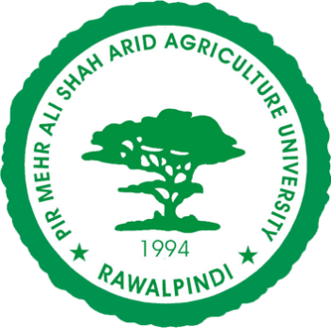

PMAS-Arid Agriculture University, Rawalpindi

University Institute of Information Technology

**Group Members:**

1. **Mehwish (20-Arid-784)**
2. **Javeria Abbasi (20-Arid-773)**
3. **Ali Haider (20-Arid-747)**

**Degree: BSSE-6(B) morning**

**Course: Object Oriented Design**

**Submission date: 12-6-2023**

**Submitted to: Mam Bushra**

**Assignment no.: 04**

Activity Diagram: for Health Care App

